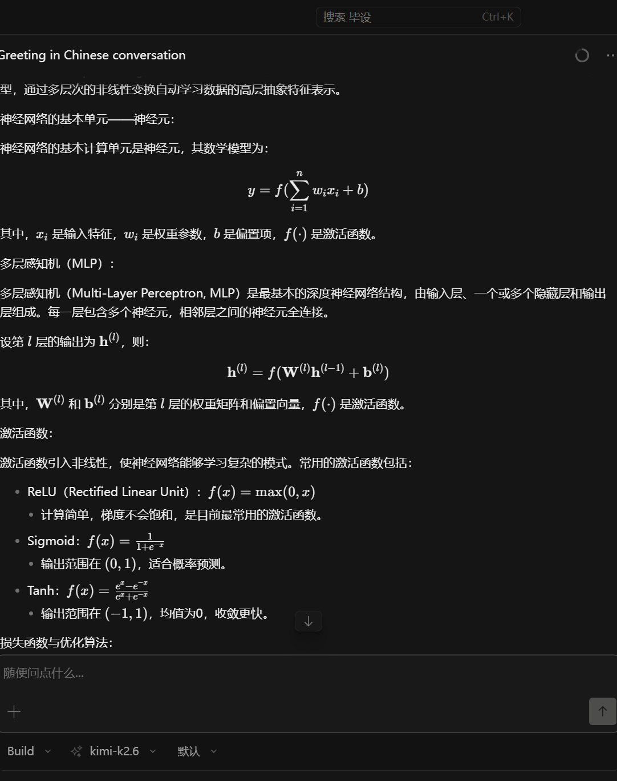
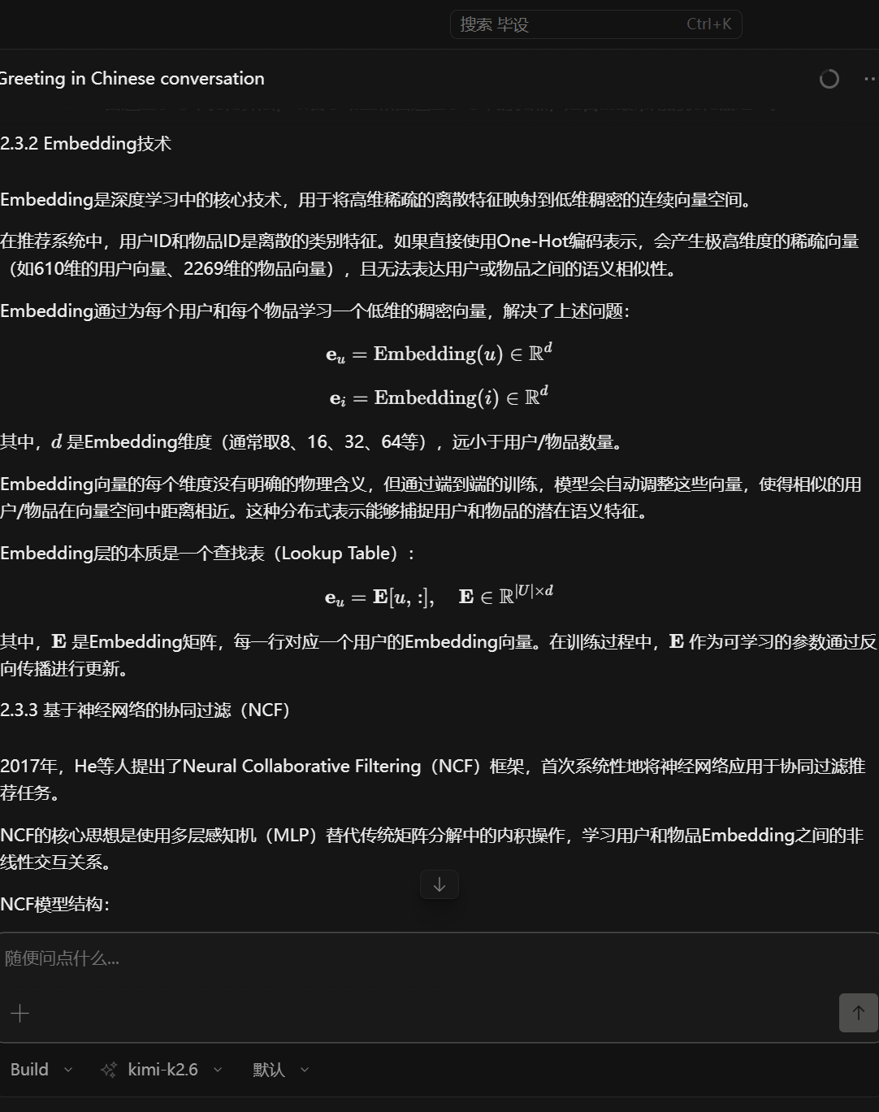
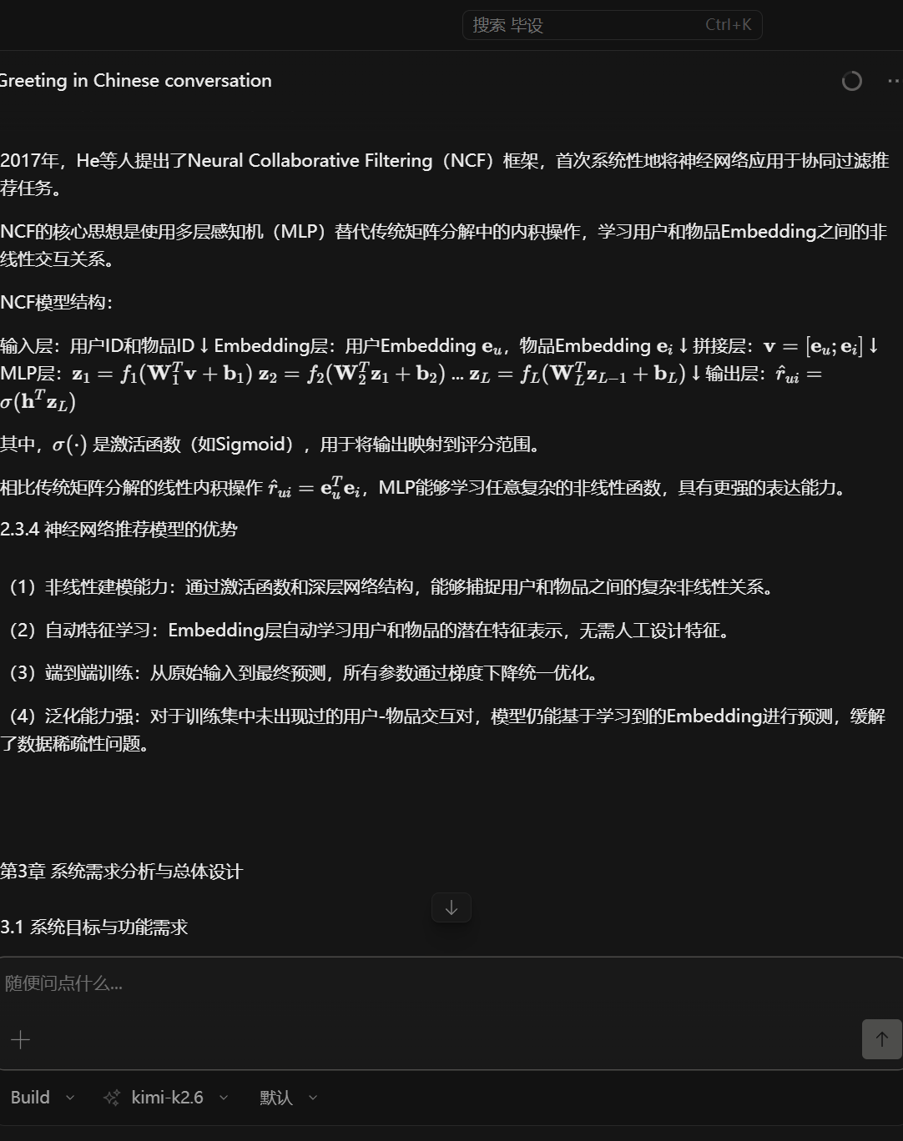
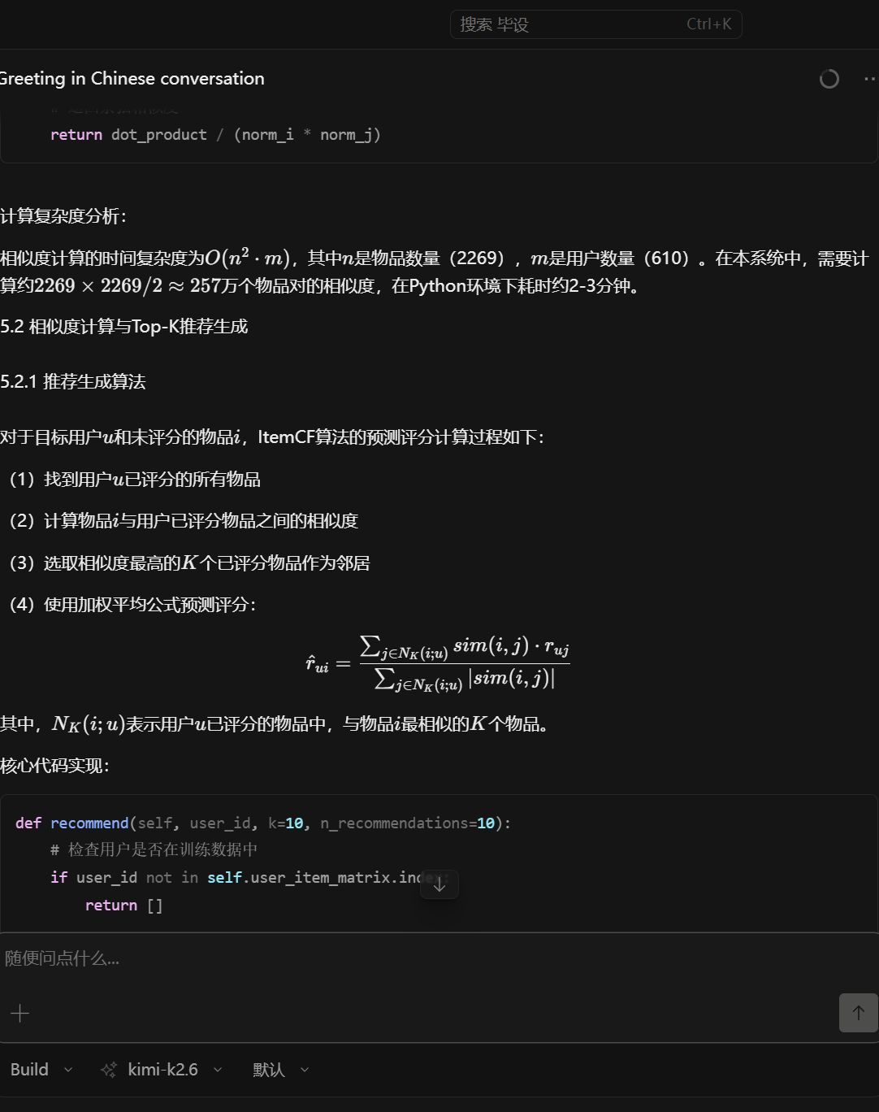

$$RMSE=\frac{1}{|T|}\underset{(u,i)∈T}{∑}(r_{ui}-{\overset{^}{r}}_{ui})^{2}$$
$$MAE=\frac{1}{|T|}\sum_{(u,i)∈T}{|}r_{ui}-{\overset{^}{r}}_{ui}|$$
$$Precision@K=\frac{|R(u)∩T(u)|}{R(u)}$$
$$Recall@K=\frac{|R(u)∩T(u)|}{|T(u)|}$$
$$NDCG@K=\frac{DCG@K}{IDCG@K}$$

